DJET Smartwatch Market Analysis
Concise market overview, competitor assessment, and proposed positioning

1. Market Overview: Smartwatch Industry

1.1 Global Smartwatch Market
The global smartwatch market competes on health monitoring, fitness tracking, connectivity, battery life, and design. Counterpoint Research reported a 4% year-on-year decline in global smartwatch shipments in Q2 2026 and forecast approximately 1% growth for full-year 2026. This makes clear differentiation and customer value important.

1.2 Egyptian Wearable Electronics Market
Euromonitor International’s July 2025 report identifies youth interest, wellness, fashion, smartphone use, e-commerce, and affordable products as factors supporting Egypt’s wearable-electronics category. Xiaomi led the category by brand volume in 2025, while Oraimo experienced dynamic growth. Publicly available summary data do not establish a standalone market size for premium smartwatches in Egypt.

1.3 Implications for DJET
- Differentiate beyond basic smartwatch functions through a clear brand identity.
- Investigate demand for Egyptian-inspired design and personalization.
- Prioritize useful features, battery performance, compatibility, and quality.
- Validate the proposed price through competitor benchmarking and customer research.

2. Competitor Profiles
Competitor | Main Products | Target Market | Marketing Approach | Strengths | Potential Weaknesses | Opportunity for DJET
Xiaomi | Redmi Watch; Xiaomi Watch | Young consumers and value-conscious technology users | Product demos, digital campaigns, value messaging | Brand recognition and broad price range | Strong competition across price segments | Egyptian-inspired design with practical features
Oraimo | Oraimo Watch series | Budget-conscious and younger consumers | Product showcases, online offers, lifestyle content | Affordable products and varied models | Differentiation and features vary by model | Build a distinctive Egyptian brand identity
Haino Teko | Fashion-oriented smartwatch models | Consumers seeking stylish, affordable watches | Design-led product displays and promotions | Wide range of visual styles | Specifications and support vary by model and seller | Combine original design with verified quality
Amazfit | Bip, GTS, GTR, Balance | Fitness and health-conscious consumers | Fitness education, feature demos, lifestyle content | Sports features and battery life on selected models | Some models sit above budget price points | Emphasize everyday style and essential functions
HOCO | Smartwatches and electronic accessories | Budget-conscious buyers and first-time users | Product showcases, retailer promotions | Affordable options and broad accessories range | Capabilities and quality vary across models | Differentiate through watch design, reliability, and support

Note: The profiles are qualitative. Product specifications, availability, prices, and local warranty coverage should be checked for the exact models being considered.

3. Competitor Comparison Table
Comparison Criteria | Xiaomi | Oraimo | Haino Teko | Amazfit | HOCO
Brand positioning | Technology and value | Affordable smart lifestyle | Fashion and affordability | Health and fitness | Budget electronics
Design | Modern and practical | Contemporary | Fashion-oriented | Sporty and functional | Trendy and varied
Health / fitness | Model-dependent health and activity tools | Core fitness functions vary by model | Basic features vary by model | Broader sports tracking on selected models | Core features vary by model
Battery life | Varies by model | Varies by model | Varies by model | Often a selling point on selected models | Varies by model
Price positioning | Budget to premium | Budget to mid-range | Budget to mid-range | Mid-range to premium | Budget to mid-range
Main strength | Brand and product range | Affordable pricing | Design variety | Fitness and training features | Affordable options
DJET opportunity | Cultural identity | Brand differentiation | Quality assurance | Lifestyle use | Reliable quality and distinctive design

4. Social Media Audit
Competitor | Main Platforms | Typical Content | Likely Engagement Focus | Opportunity for DJET
Xiaomi | Instagram, Facebook, TikTok, YouTube | Product demos and technology features | Brand awareness and value | Show design and useful features in short videos
Oraimo | Instagram, Facebook, TikTok | Product showcases and promotions | Affordability and product discovery | Use local offers and Egyptian storytelling
Haino Teko | Instagram, Facebook, TikTok | Watch designs and visual displays | Fashion and affordability | Show DJET’s original design and quality
Amazfit | Instagram, Facebook, YouTube, TikTok | Fitness tips and feature demonstrations | Health and active lifestyle | Connect practical functions with everyday life
HOCO | Instagram, Facebook, TikTok | Product displays and promotions | Affordable electronics | Build a focused smartwatch identity

Note: This is a qualitative audit, not a measured account-performance study. For a true audit, compare the most recent 10 posts per brand or a shared 30-day period; record posting frequency, views, engagement, content mix, and visible brand replies.

5. Competitor Content Analysis
Competitor | Main Themes | Content Style | Key Message | Lesson for DJET
Xiaomi | Technology, product features, value | Product demonstrations | Useful technology at varied prices | Explain features and value clearly
Oraimo | Affordable devices and offers | Short videos and promotions | Smart lifestyle at accessible prices | Pair accessible pricing with clear brand identity
Haino Teko | Fashion and watch design | Visual product displays | Style at accessible prices | Highlight Egyptian-inspired aesthetics
Amazfit | Fitness, health, sports, battery | Educational and fitness content | Performance for active lifestyles | Show practical, everyday benefits
HOCO | Electronics and accessories | Product showcases and deals | Accessible technology | Differentiate through quality and design

Key finding: Competitors mainly emphasize affordability, technology, fashion, or fitness. DJET can test whether Egyptian cultural identity and futuristic design create a meaningful point of difference.

6. Competitor Positioning Map
The map provides a conceptual comparison of price positioning and design focus. Competitor placements are indicative, based on broad positioning rather than measured prices or customer-perception scores.
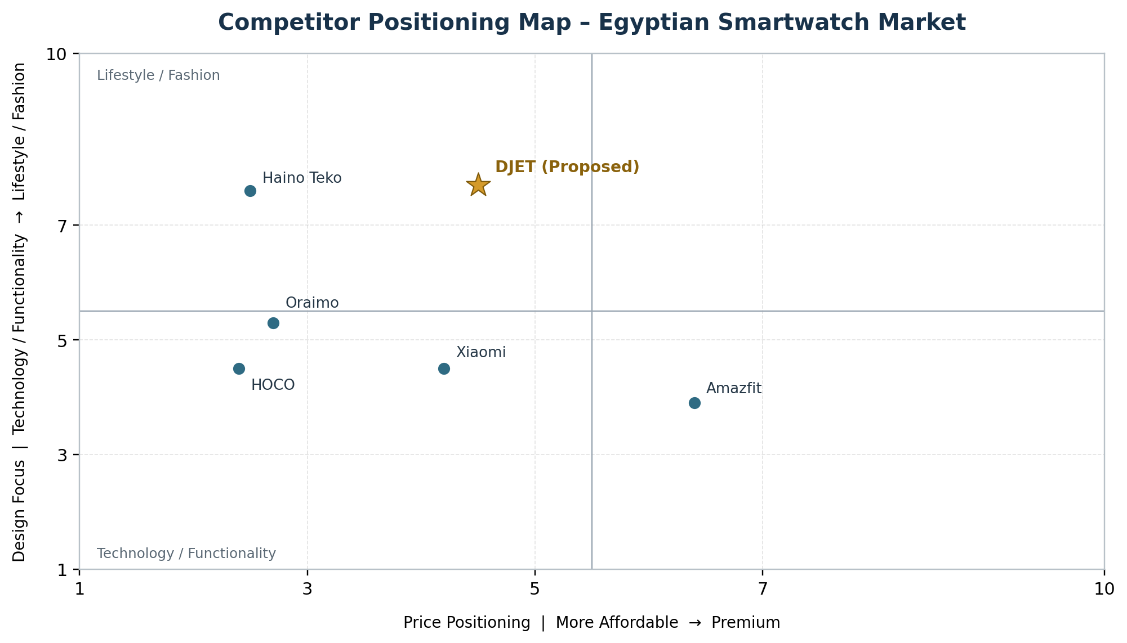
Proposed DJET position: affordable-to-mid-range with lifestyle-focused design, Egyptian-inspired visual identity, and practical features.
Note: Validate this map using current Egyptian retail prices and customer research before presenting the positions as market evidence.

7. Competitor Strengths and Weaknesses
Competitor | Strengths | Potential Weaknesses | Opportunity for DJET
Xiaomi | Brand recognition and product variety | Strong competition across segments | Build a distinct Egyptian identity
Oraimo | Accessible pricing and broad device range | Some models offer limited differentiation | Offer a distinctive design and clear value
Haino Teko | Variety of fashionable designs | Specifications and support vary by seller/model | Emphasize verified specifications and warranty
Amazfit | Fitness features and battery performance on selected models | Advanced models may cost more | Target style-conscious everyday users
HOCO | Affordable products and accessories | Features and quality vary by model | Focus on reliability and after-sales support

8. Customer Review Themes
Review Theme | Common Concern | Implication for DJET
Battery life | Usage time may differ from advertised life | Test under realistic settings; communicate expectations
Tracking reliability | Users may question step, heart-rate, GPS, or sleep accuracy | Prioritize dependable core features
Design and comfort | Weight, fit, appearance, and straps affect satisfaction | Pair distinct styling with everyday comfort
Price and value | Customers weigh features against cost | Offer a clear balance of design, quality, and price
Compatibility and software | App support, pairing, and notifications can vary | State compatible phones and test connection stability
Durability and service | Defects, charging, and warranty handling matter | Quality-check units and establish clear warranty support

Note: These are review themes to investigate, not statistical findings for all Egyptian smartwatch consumers.

9. Evidence of Customer Concerns (Actual Review Examples)
The examples below illustrate individual public customer experiences with selected models. They help identify issues to test; they do not establish how common a problem is or prove that every model from a brand has the same weakness.
Brand / Model | Review Example (Paraphrased) | Concern to Investigate
Xiaomi Redmi Watch 5 Active | A Reddit user reported getting about 7–8 days rather than the advertised 14 days under the user’s settings. | Battery-life expectations
Oraimo Watch 2R | An Egyptian Amazon reviewer praised the appearance and screen visibility but said the vibration was not very strong; another review noted battery life below four days. | Comfort, alerts, and battery life
Haino Teko RW44 / related models | Marketplace reviews include complaints about charging and product condition, alongside positive comments about design. | Quality control and after-sales service
Amazfit Bip 6 | A user review praised the display and GPS but described battery life as average and raised sleep-tracking concerns. | Battery and tracking performance
HOCO Y16 | A verified buyer reported substantial battery drain during a workday and difficulty connecting calls to an iPhone. | Battery and phone compatibility

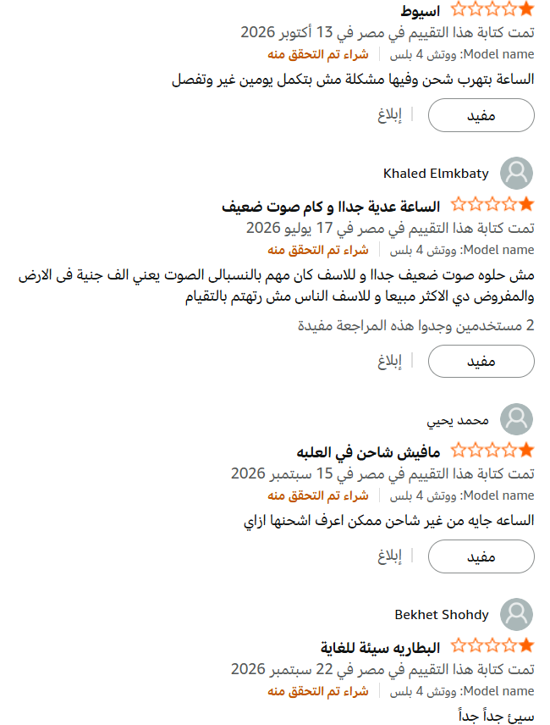

10. Market Opportunities
Opportunity | Market Context | Recommended Action for DJET
Egyptian cultural identity | Existing competitors chiefly promote technology, price, fashion, or fitness | Test modern Egyptian-inspired patterns, symbols, and storytelling
Design and personalization | Consumers may use watches as both devices and accessories | Explore watch faces, straps, and distinctive design options
Affordable value | Products compete across different price levels | Benchmark prices and balance essential features, design, and quality
Battery and reliability | Customer reviews raise practical performance concerns | Test battery, notifications, tracking, and durability before launch
Digital marketing | Short-form video and product demonstrations help introduce products | Prioritize Instagram and TikTok; use Facebook for local reach and YouTube for demos
Local market fit | Budgets and feature preferences vary by consumer segment | Survey Egyptian consumers on price, features, style, and compatibility

11. Recommended Competitive Gap
Proposed positioning: DJET is a proposed smartwatch brand that combines Egyptian-inspired design, futuristic aesthetics, and practical everyday functionality at a competitive price.
- Design: create a distinctive but wearable Egyptian-inspired visual identity.
- Functionality: prioritize reliable core features, battery performance, notifications, and smartphone compatibility.
- Value: choose a price range through local competitor benchmarking and customer research.
- Marketing: use short videos and local lifestyle storytelling to explain the product’s value.
- Validation: conduct customer surveys or concept tests before treating this opportunity as proven demand.
Conclusion: DJET’s potential competitive gap is the combination of cultural identity, practical smartwatch features, and competitive pricing. This remains a strategic hypothesis until validated with customer research, price benchmarking, and product feasibility testing.

